Nikkiso Clean Energy & Industrial Gases Group – Cooperation with NEA Brasil

FOR IMMEDIATE RELEASE

Irvine, CA, August 8, 2023 - Cryogenic Industries, Inc.’s Nikkiso Clean Energy & Industrial Gases Group (Group), whose member companies are ultimately owned by Nikkiso Co., Ltd (Japan), is pleased to announce that Cryogenic Industries Service Companies, LLC dba Nikkiso Cryogenic Services (NCS) of our Cryogenic Service Unit entered into a Cooperation Agreement with Neuman & Esser (NEA) Brasil as of January 27, 2023.

As an authorized Nikkiso service center, NEA Brasil will be the local solution provider for Nikkiso products, including ACD cryogenic pumps and Turboexpanders, installed in Brazil. The objective of this cooperation will help reduce lead times for repairs, improve customer service in the field, and increase the number of service centers globally to regionally support our customers, while maintaining a high level of quality of service, spare parts, and technical support.

The cooperation with NCS, a leading service provider for cryogenic equipment, will be a next strategic step. Nikkiso offers a wide variety of services for cryogenic pumps and Turboexpanders manufactured by ACD and other companies. NCS has 18 global service facilities to provide service for the industrial gas and air separation industries, enhanced oil recovery operations, marine and clean energy and alternative fuels projects.

For 25 years, NEA Brasil has been offering comprehensive engineering know-how, customized solutions and services for reciprocating compressors, diaphragm compressors, pendulum roller mills, impact classifier mills, classifiers and filters, spare parts, and revamps. Once certified for competency, NEA Brasil will expand their expertise in cryogenic pumps and Turboexpanders.
NEA Brasil Contact:
Bruno Corrêa
Office: +55 31 2126-9555
Mobile: +55 31 99788-9560
Email: bruno.correa@neac.com.br

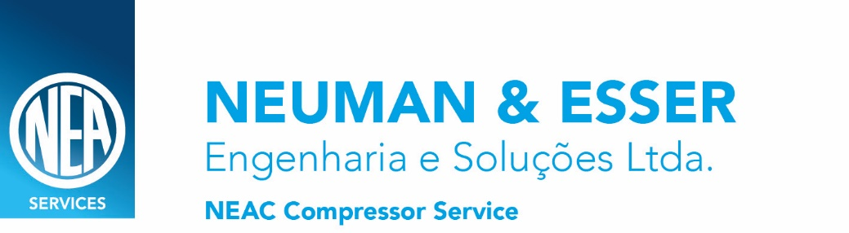

About Nikkiso Clean Energy & Industrial Gases Group
Nikkiso Clean Energy & Industrial Gases Group is part of the Industrial Division of Nikkiso co. Lt. Japan. The Group operates in the US, under Cryogenic Industries, Inc. (a member of Nikkiso Co., Ltd.). The Group member companies manufacture, and service engineered cryogenic gas processing equipment (pumps, turboexpanders, heat exchangers, etc.), and process plants for Industrial Gases, Natural Gas Liquefaction (LNG), Hydrogen Liquefaction (LH2) and Organic Rankine Cycle for Waste Heat Recovery. Founded over 50 years ago, Cryogenic Industries is the parent company of ACD, Nikkiso Cryo, Nikkiso Integrated Cryogenic Solutions, Cosmodyne and Cryoquip and a commonly controlled group of approximately 20 operating entities.

###

For more information, please visit www.NikkisoCEIG.com and www.Nikkiso.com.

MEDIA CONTACT:

Nikkiso Marketing Department

+1 951.528.2076

Marketing@nikkisoceig.com

